DA Camp _ Task1 | Title
Data Analyst _ Hash Plus | Camp
Orgwan Dandeni | Name
Data Analyst | Specialty
0r6wan@gmail.com | Email

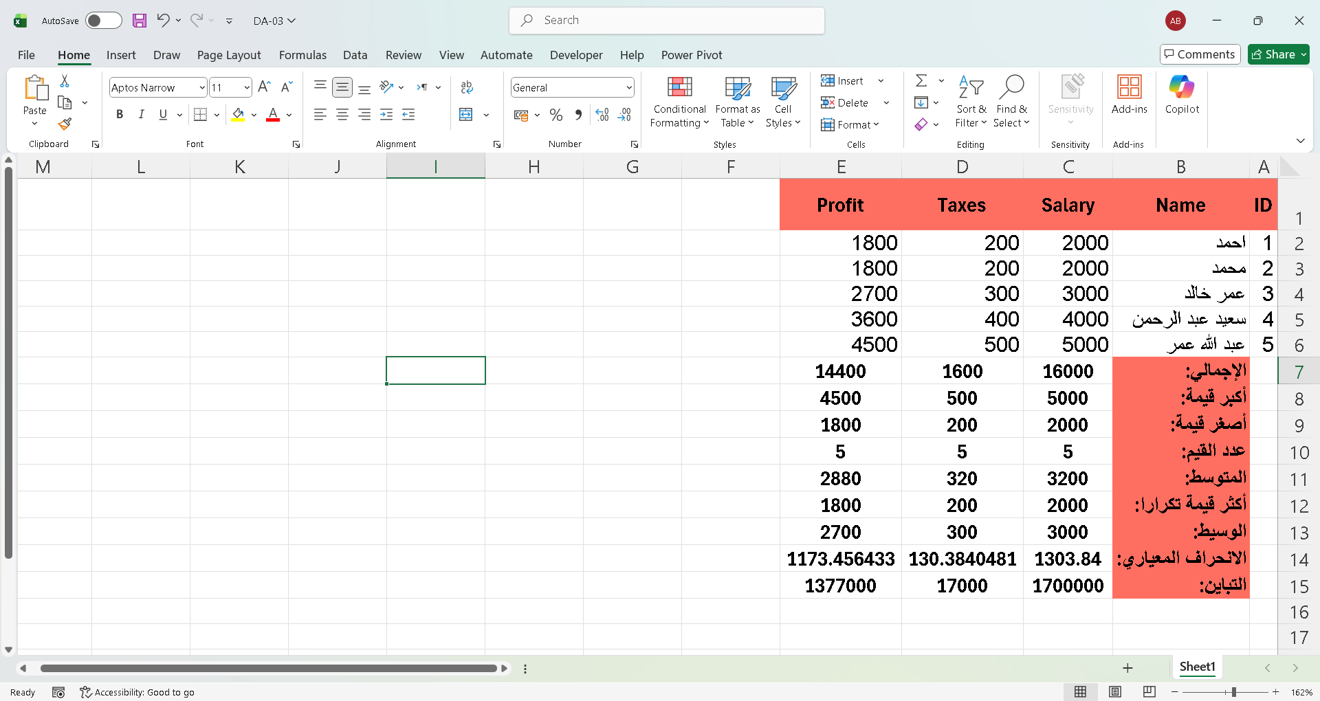

Average
I divided the sum of the values by their count, where I obtained the sum using SUM and the number of values using COUNT

Most Frequently Used Value
To calculate the most frequently used value, I used the MODE function as follows:
"=MODE(C2:C6)"

Median
To calculate the median, I used the MEDIAN function as follows:
"=MEDIAN(C2:C6)"

Standard Deviation
I looked up the topic of calculating the standard deviation and found that the STD function does not work on its own, so I searched for the correct formula and calculated it as follows:
"=STDEV.S(C2:C6)"

Variance
I calculated the variance using the VAR function as follows:
"=VAR.S(C2:C6)"

